PROTECT SECTION 106
America can build for the future without erasing its past.

OUR ASK TO SENATOR/REPRESENTATIVE ____________________: Oppose legislative or regulatory efforts to weaken Section 106 of the National Historic Preservation Act.

What Section 106 does
For sixty years, Section 106 has given Tribal Nations, communities, local governments, preservation organizations, and the public a voice before federally involved projects damage or destroy historic places. It requires federal agencies to identify historic properties that may be affected, consider the consequences of their decisions, and consult about ways to avoid, minimize, or mitigate harm.
Section 106 does not automatically stop projects. It helps us make better decisions before something irreplaceable is lost.

DISCOVER  Historic places, archaeological resources, sacred sites, and other history before they are destroyed. | GIVE PEOPLE A VOICE  Communities and Tribal Nations can participate before federal decisions become irreversible.
IMPROVE PROJECTS  Early consultation can identify better locations, designs, approaches, and mitigation. | PRESERVE HISTORY  Even when projects proceed, important places and information can be documented and harm reduced.

Why this matters here at home
LOCAL SECTION 106 STORY — Customize this box before your meeting in about 75 words: What place was at risk? What project triggered review? What did consultation accomplish? Did the project ultimately proceed?

[Insert your local story here. Add one small photo if useful.]

An extraordinary national coalition is speaking up
Nearly 700 organizations and Tribal Nations representing more than 7 million Americans have joined together to defend Section 106. They include organizations and people who work every day with historic places, infrastructure, development, Tribal heritage, archaeology, architecture, museums, local government, and communities.
We support making federal review more efficient and effective. But efficiency should come from better planning, earlier consultation, adequate staffing, technology, and evidence-based improvements—not by silencing communities or weakening the protections Congress created.

What we are asking Congress to do
- OPPOSE proposals that weaken Section 106’s protections for historic places.
- PROTECT meaningful consultation, public participation, and the rights and role of Tribal Nations.
- PRESERVE consideration of ways to avoid, minimize, or mitigate harm.
- SUPPORT evidence-based improvements that make Section 106 work better without sacrificing its core protections.

IMPROVE SECTION 106. MAKE IT WORK EVEN BETTER. BUT DON’T WEAKEN IT.

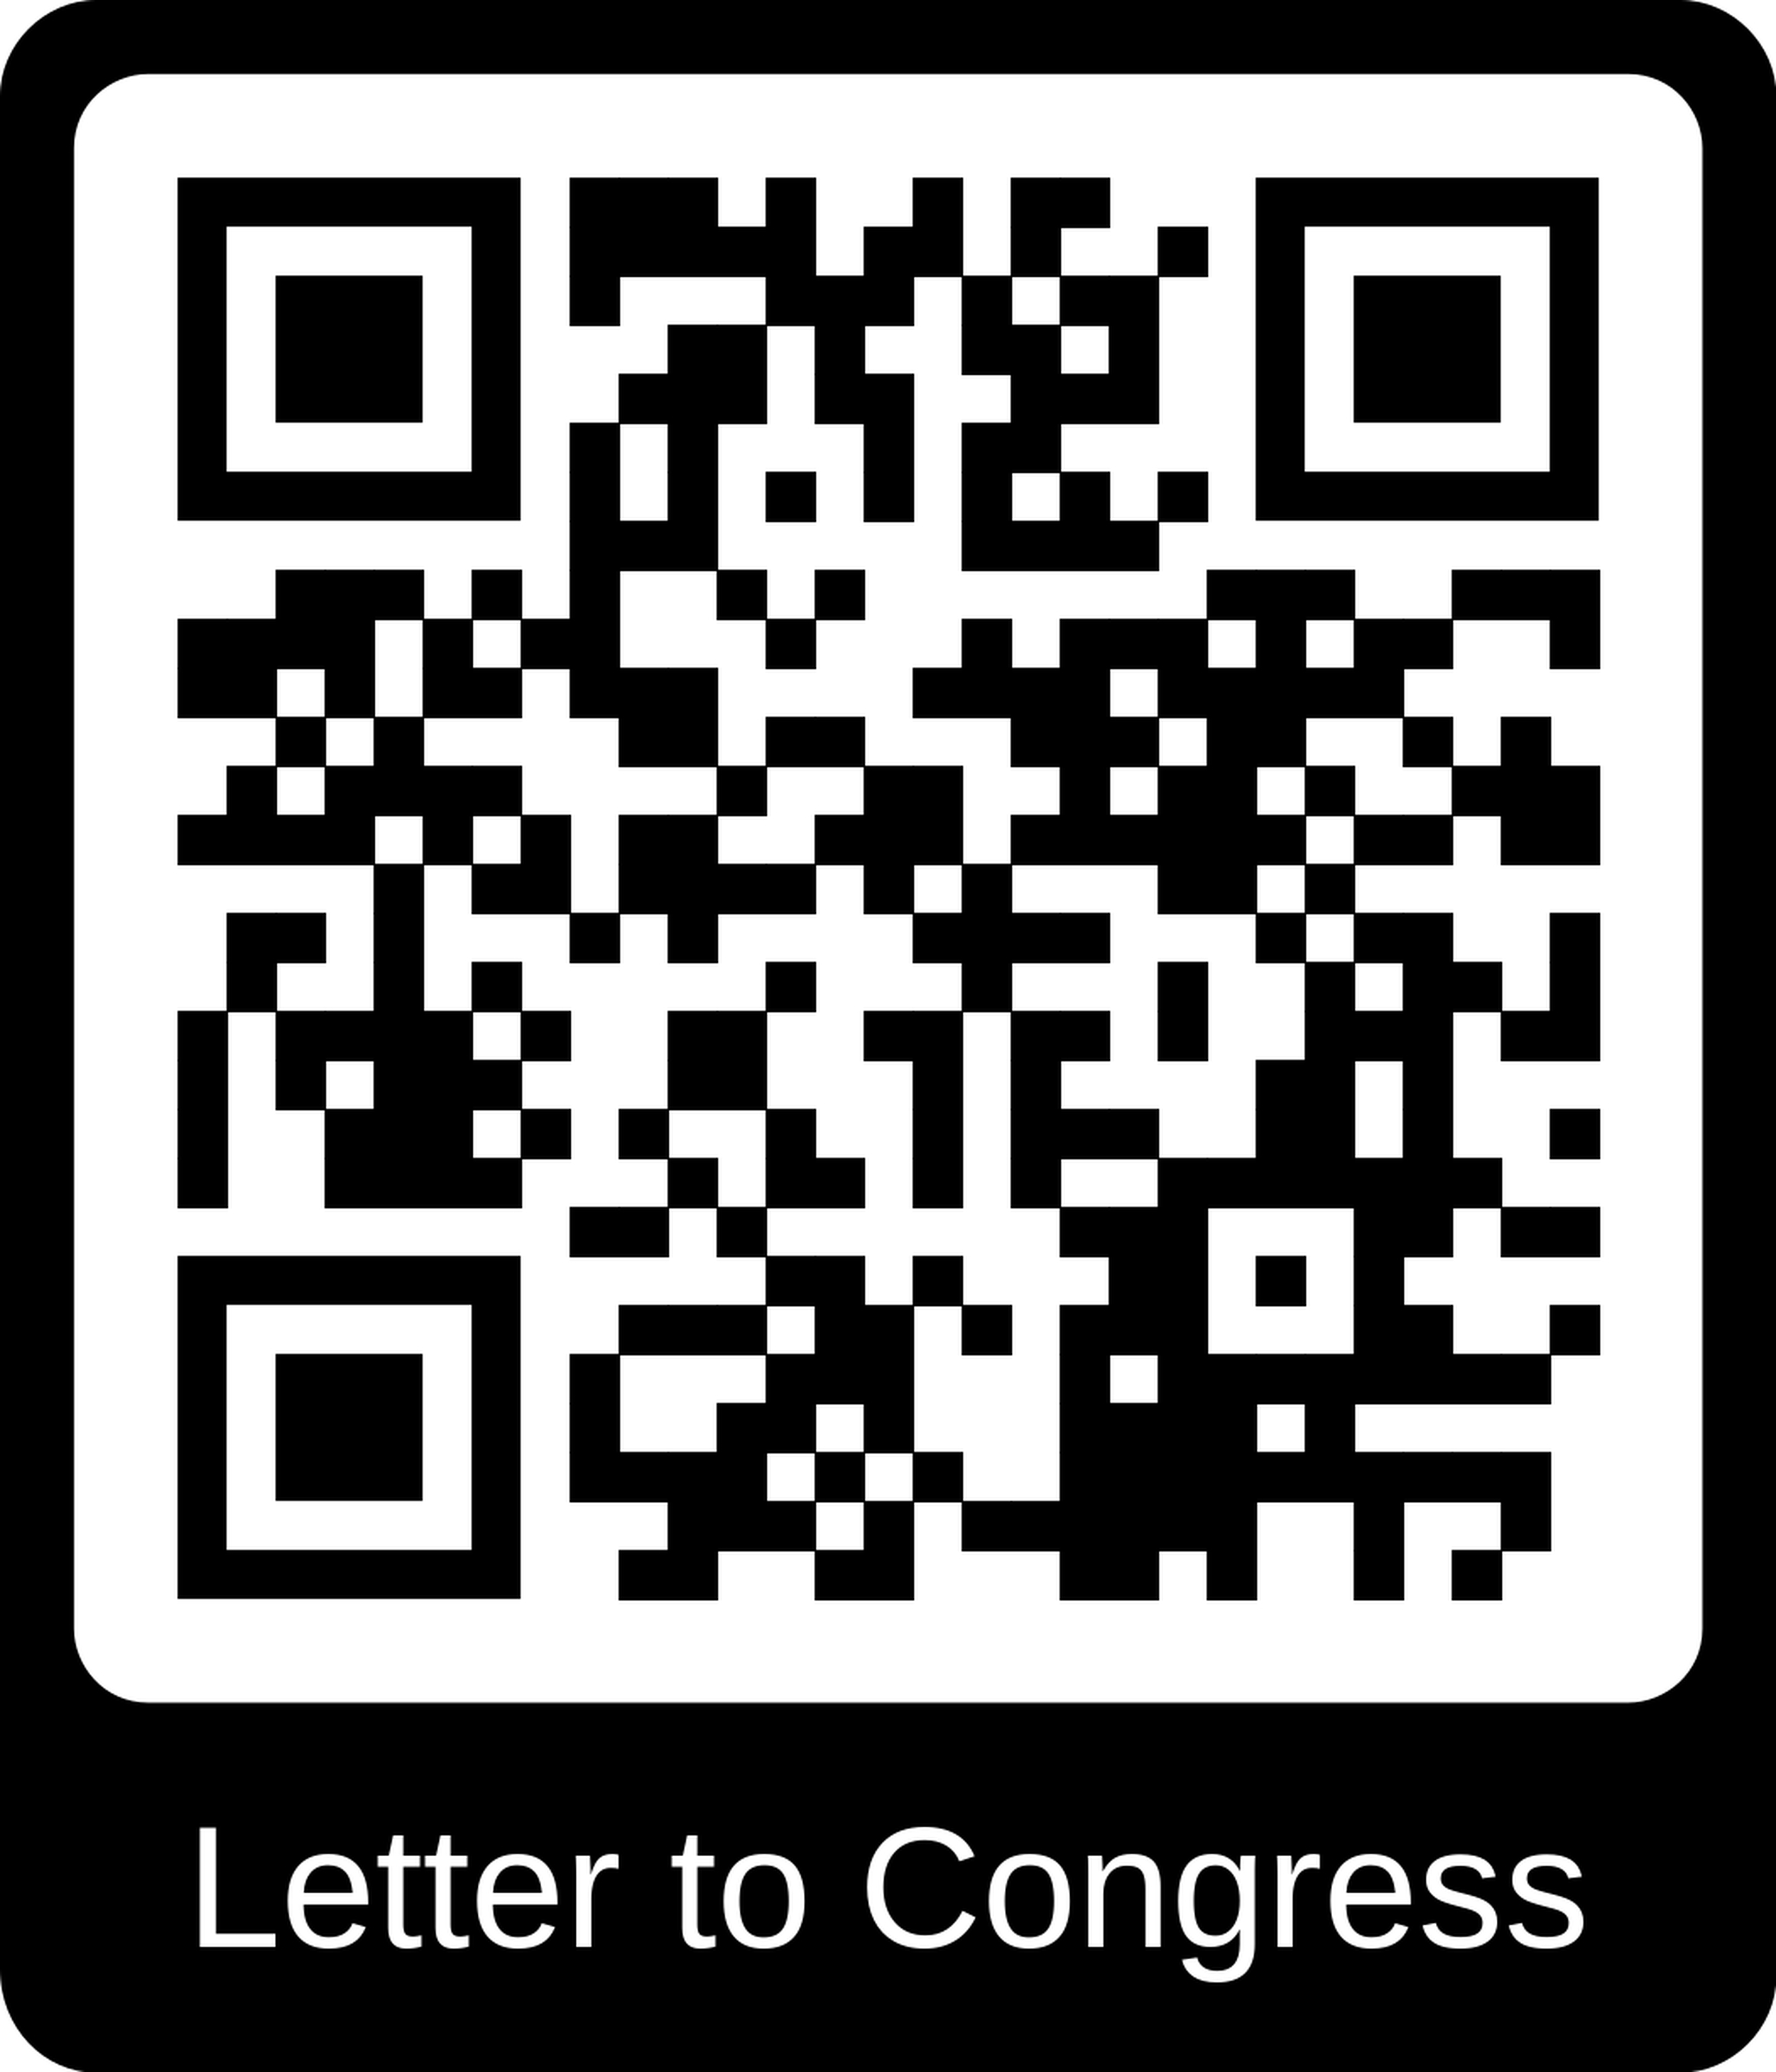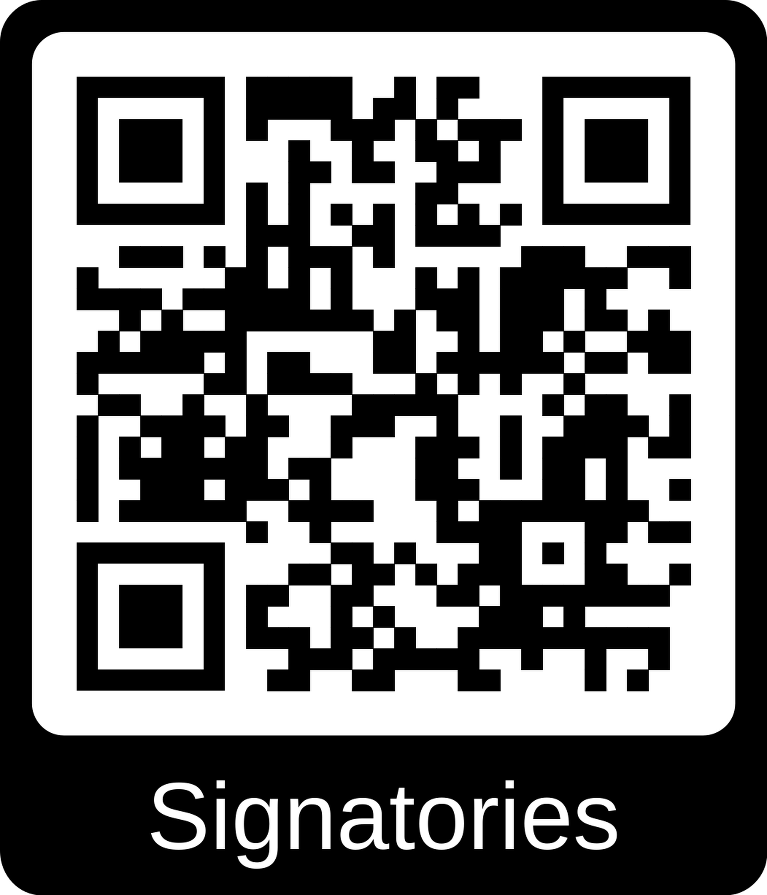

Press Release - https://culturalheritagepartners.com/wp-content/uploads/2026/08/20260827-press-release-section-106-coalition-open-letter-to-congress.pdf
Letter to Congress - https://culturalheritagepartners.com/wp-content/uploads/2026/08/20260828-section-106-coalition-open-letter-and-brief-to-congress-updated.pdf
Signatories - https://culturalheritagepartners.com/open-letter-to-congress-from-national-coalition/
Learn More - https://culturalheritagepartners.com/war-room-for-threats-to-section-106/

